Southern Maryland Regional LIbrary Association (SMRLA)
Request for Proposal (RFP):
Providing Library Delivery and Sorting Services 2023
Issued on April 12, 2023

Responses due on May 11, 2023, at 4:30 PM Eastern Time

Table of Contents
Notice of Request for Proposals 3
RFP Website: 3
Contact Information: 3
Introduction/Purpose/Statement of Work of Solicitation 5
Purpose and Background 6
Statement of Work 8
Schedule of Events 9
General Instructions for Respondents 10
Proposal Requirements 13
Evaluation of Proposals 15
Exhibit A: Route, Stops, and Related Data 16
Exhibit A: Part 2: Trends in Items Received 17
Exhibit A: Part 3: Branch Delivery Sample 20
Exhibit B: SMRLA Drivers Manual July 2021 revision 25
Exhibit C: Containers and Labels 26
Exhibit D: Sorting 30
Exhibit E: Glossary of Terms 33
Response Template 34
Attachment A: Cover Letter 35
Attachment B: Table of Contents 36
Attachment C: Attachment Checklist 37
Attachment D: Minimum Qualifications 38
Attachment E: Proposal Questionnaire 39
Part 1 - Attachment E: Proposal Questionnaire 39
Part 2 - Attachment E: Proposal Questionnaire 40
Attachment F: Cost Proposal 48
Attachment G: Respondent References 51
Attachment H: Authorization Agreement 52
Attachment I: Certificate of Independent Price Determination 53

Notice of Request for Proposals
Southern Maryland Regional LIbrary Association (SMRLA)
Request for Proposal (RFP): Providing Library Delivery and Sorting Services 2023
Notice is hereby given that the Southern Maryland Regional Library Association, Inc. (hereinafter referred to as SMRLA) is requesting proposals for a firm or organization who will provide delivery and sorting services to SMRLA and libraries in the Calvert County, Charles County, and St. Mary’s County areas in Maryland.
Respondents should not construe from this legal notice that SMRLA intends to enter into a contract with the Respondent unless, in the opinion of SMRLA, it is in the best interest of SMRLA to do so. SMRLA reserves the right to negotiate final contractual terms with the successful Respondent.

RFP Website:

The Request for Proposal (RFP) documents are available at the
RFP website: https://smrla.org/rfp/.

Contact Information:
To request the RFP documents by e-mail, postal mail, or fax, please contact:

Ashley Teagle
e-mail rfp@smrla.org
Postal Mail P.O. Box 459, Charlotte Hall, MD 20622
Physical Address for other Carriers: 37600 New Market Rd, Charlotte Hall, MD 20622
fax 301-884-0438
SMRLA will record and provide answers to any questions or requests submitted to the contact information above for clarifying information about the RFP by May 1, 2023. As questions are received, the answers will be posted at the RFP website listed above.
On April 24, 2023, a pre-bid conference will be held with the RFP Committee via Zoom and the log in information will be posted at the RFP website listed above.
On April 28, 2023, SMRLA offers potential respondents an opportunity to visit our facilities and see the vehicle, materials prepared for shipping and to visit the co-located library to see materials prepared for shipping. The time and date will be posted at RFP website listed above.
Respondents must submit written proposals in a sealed package labeled Southern Maryland Regional Library Association Delivery Study Addressed to SMRLA at:
Southern Maryland Regional Library Association

Attn: Ashley Teagle
Mailing Address: P.O. Box 459, Charlotte Hall, MD 20622
Physical Address for other Carriers: 37600 New Market Rd, Charlotte Hall, MD 20622

SMRLA will accept all proposals received on or before May 11, 2023, at 4:30 p.m. SMRLA will not accept proposals that are received after the deadline. SMRLA will open proposals at 1:00 p.m. on May 17, 2023, via Zoom. Please check our website the day before that date, for the Zoom link.
SMRLA reserves the right to reject any or all proposals, and to waive any errors or corrections in a proposal or in the proposal process. SMRLA will award the contract based on a review and analysis of the proposals that determines which proposal best meets the needs of SMRLA. Following the review and analysis of all responsive proposals, SMRLA will make a recommendation to its Board of Trustees at its regularly scheduled meeting.

Introduction/Purpose/Statement of Work of Solicitation
Introduction

SMRLA shall conduct all procurement transactions in a manner that provides maximum open and free competition. SMRLA must share with every Respondent all information necessary for submitting a competitive proposal.

Outlined below are competitive bidding basic standards:

- The purpose of soliciting competitive proposals is to secure objectives in the most effective manner and avoid the possibilities of graft, fraud, collusion, etc.

- SMRLA released this RFP to benefit SMRLA and not the Respondents.

- Fulfillment of RFP specifications is based on full and fair competition and acceptance by SMRLA of the most responsive and responsible Respondent to SMRLA’s requirements, as determined by SMRLA when evaluating proposals based on the criteria contained in the RFP.

- The RFP must provide a basis for full and fair competition among Respondents to a common standard, free of restrictions that tend to stifle competition.

To respond to this RFP, interested Respondents must present evidence of experience, ability, and financial standing necessary to meet the requirements stated in this RFP. SMRLA will measure this evidence by scoring the proposals, using a point system that will rank each proposal from highest to lowest, to determine which proposals they will consider for the award of a contract.

To be competitive in this solicitation, the Respondent must:
- Carefully read the entire RFP, attachments, exhibits, addenda, and SMRLA responses to questions before submitting a proposal
- Ask appropriate questions or request clarification before the deadline in the RFP
- Submit all required responses by the required deadlines
- Follow all instructions and requirements of the RFP thoroughly and appropriately

If a Respondent discovers any ambiguity, conflict, discrepancy, omission, or other errors in this RFP, the Respondent shall immediately notify SMRLA of the error in writing and request clarification or a modification of the RFP. If the Respondent fails to notify SMRLA of the error prior to the date for submission of proposals, and is awarded the contract, the Respondent shall not be entitled to additional compensation or time by reason of the error or its later correction.

Purpose and Background

The purpose of this Request for Proposal (RFP) is to hire a contractor to perform the work of SMRLA’s current delivery system. The successful Respondent will provide services to the Southern Maryland Regional Library Association, Inc. (hereinafter referred to as SMRLA) as described in the Statement of Work.

SMRLA’s goals are to meet the current and future delivery needs of SMRLA and the public libraries in the region. Note that a small part of the delivery service includes academic and school libraries. SMRLA seeks to maximize cost effectiveness and efficiency as it relates to the continuation of service and staffing.

SMRLA is a regional resource center for the public libraries in Calvert, Charles, and St. Mary’s counties. It was formed in 1959 to provide additional services to the citizens of rural Maryland through their local county libraries. It is part of a statewide resource network of three regional centers, working in collaboration with the State Library Resource Center, to provide efficient, economical, and coordinated library services county libraries cannot adequately provide themselves.

SMRLA, by providing services to the three rural Southern Maryland public libraries, serves a
population of 366,724 people (2020 census data) across a region of over 1,752 square miles. At present, eleven public library buildings and two bookmobiles serve the residents of
Southern Maryland.

The delivery system consists of one delivery route that runs Monday-Friday (excluding holidays) to each brick-and-mortar public library building in Calvert, Charles, and St. Mary’s County and a small number of other stops.. The delivery team consists of a driver and helper who are employed by agencies. The truck is leased and serviced by Ryder.

There are 11 daily (M-F) physical stops at public library facilities, two weekly stops at college library designations, and one “as needed” stop at the Calvert County Board of Education. One stop (the first of the day) includes the transfer of materials from SMRLA itself and a branch library as the building is shared. The team also stops (M-F) at the Charlotte Hall Post Office to pick up and delivery mail from SMRLA and at Quarles for fuel, as needed. The route averages 190 miles and about eight and one-half hours a day. The team delivers materials to/from the locations listed in Exhibit A: Part 1: Route, Stops, and Related Data.

SMRLA currently provides delivery and sorting with a leased 26-foot box truck and a contracted CDL-licensed driver and a helper on a five-day-per-week. Totes are labeled by the libraries and are sorted on board for same or next-day delivery. The truck is parked overnight, and the route begins and ends at SMRLA headquarters in Charlotte Hall, MD (a dual use building shared by SMRLA and the Charlotte Hall Library).

The current route includes 12 daily stops (2 are co-located), 2 weekly stops, and 1 on-demand stops. Total public library (daily stops) shipping averages 2,530 items per day. During a sample week in March 2023 840 totes holding 12,605 items were shipped by libraries and 812 totes holding 13,126 items were received by libraries.

Growth in volume of items shipped was seven percent in the Jan-Mar period in 2023 over 2022. We estimate that this would mean a growth in totes shipped of one or two percent because only one-third of totes shipped are full and the average number of items in a tote is 17. Turnaround time for most items is one or two delivery days.

Items shipped are books, DVDs, CDs, library paperwork, and other library materials, such as story time kits, shipped in plastic totes. Weekly stop cargo is normally one canvas bag shipped and received per stop.

Proposals may be submitted to replicate the on-board sorting model. Bidders may also submit proposal for alternative sorting and route structures.

Statement of Work

SMRLA is seeking a contractor to provide:
  - Proposals for delivery and sorting services with the following features.
    - Daily delivery and sorting of library materials on a schedule as frequent as is currently provided.
    - Minimal increase in the workload of library staff in receipt of and in preparing materials for delivery.
    - Clear, predictable pricing proposal
    - Key Performance Indicators (Quality Standards Appropriate for the Library Industry)
      - Quality of service with turnaround time of next working day for 90% of materials and 99% by the following working day.
      - Quality of service with on time delivery to all stops on 99% of working days.
      - Quality of service with 99% accuracy of delivery of totes for all stops.
      - Quality of service with no damage to library materials or property.
      - Vendor shall provide SMRLA and libraries with prompt reimbursement within 14 days to cover standard library replacement costs for damaged or lost materials for which a valid claim was submitted.
      - Quality of service with 99.9% complete stops.
      - Quality of service with Contractor informing SMRLA within one hour when any route is delayed, curtailed, or canceled.
      - Quality of service with 99.9% accurate invoices.
      - Quality of service with 99% of weekly reports provided by Tuesday of the following week.
      - Quality of service with drivers maintaining a neat, well-groomed appearance.
      - Reliable backups for personnel and vehicle with quality standard of 99% all scheduled stops are made.
      - Recovery after issues, e.g., weather emergency, staff absence, or vehicle problems, in which normal service is resumed within two working days.
    - Fiscal recognition to SMRLA when quality standards are not met.
      - Discounted service when quality of service falls below contracted standards.
      - Payment for lost or damaged library materials within 14 days of valid claim.
    - A one-year agreement with up to three annual renewals.

Schedule of Events
Event | Date/Time Eastern Time
Board Meeting – RFP Notice | April 12, 2023
Release of RFP | April 12
First Public Notice | April 12
Second Public Notice | April 14
Pre-Bid Conference (Virtual) | April 24 9:00-10:00am
Pre-Bid Visit to SMRLA and one Library | April 28 time tba
Respondent Question Submission Deadline | May 1
SMRLA Provides Answers | May 3
Deadline for Submission of Sealed Proposal | May 11 4:30pm Eastern Time
Proposals Opened | May 17 1:00pm
Proposals Evaluation Period | May 17 - May 24
Finalist Virtual Interviews | tba
Board Meeting – Proposal Approval | July 11
Anticipated Contract Award Date | August 1
Anticipated New Service Beginning Date | September 1, 2023

Note: SMRLA will make every effort to adhere to the schedule. However, SMRLA reserves the right to amend the schedule, as necessary, and will post a notice of said amendment at https://smrla.org/rfp/.

General Instructions for Respondents
Prepare proposals simply and economically. Provide a straightforward concise description of the Respondent’s capability to satisfy SMRLA’s requirements. Emphasis should be placed on completeness and clarity of content.

- Submit proposals for the performance of all the services described within this RFP. SMRLA will not consider any deviation from these specifications and will reject such proposals.

- SMRLA may reject a proposal if the proposal is conditional or incomplete, deemed
nonresponsive, or if it contains any alterations of form or other irregularities of any kind. SMRLA may reject any or all proposals or waive any immaterial deviation in a proposal. SMRLA’s waiver of an immaterial deviation shall in no way modify the RFP document or excuse the Respondent from full compliance with all other requirements if awarded the contract.

- Respondents are responsible for the costs of developing proposals and shall not charge SMRLA for any preparation costs.

- Respondents may modify their proposal after submission by withdrawing the original proposal and resubmitting a new proposal prior to the submission deadline. SMRLA will not consider proposal modifications offered in any other manner, either oral or written.

- Respondents may withdraw their proposal by submitting a written withdrawal request to SMRLA, signed by the Respondent or their authorized agent, through the contact person named in the “Contact Information” provided in the General Instructions for Respondents. Thereafter, a Respondent may submit a new proposal prior to the proposal submission deadline. Respondents may not withdraw their proposal without the approval of SMRLA after the proposal submission deadline.

- SMRLA may modify the RFP prior to the date given for submission of proposals by posting an addendum on https://smrla.org/rfp/. SMRLA will notify any Respondents who have already submitted a proposal, so they can obtain any addenda from SMRLA’s Web site, or request it by e-mail, postal mail, or fax, and withdraw or modify any submitted proposal.

- SMRLA reserves the right to reject any and/or all proposals at its discretion. If all proposals are rejected, SMRLA is not required to award a contract.

- SMRLA will consider a joint proposal submitted by two or more entities provided the proposal is clearly identified and includes a single, lead entity for interaction with SMRLA.

- Additional charges for regular or express delivery, drayage, parcel post, packing, cartage, insurance, license fees, permits, or for any other purpose shall be included (and separately identified) in the proposal.

- All proposals shall include the forms provided as attachments this RFP. Respondents may copy these forms. A proposal is considered responsive if it follows the required format, includes all attachments, and meets all deadlines and other requirements outlined in this RFP.

- SMRLA shall not accept proposals after the submission deadline specified in the RFP and shall return the unopened proposals to the respective Respondents. SMRLA will not consider late proposals under any circumstances.

- Respondents are responsible for examining the entire RFP package, seeking clarification for any item or requirement that may not be clear to them, and checking all responses in their proposal for accuracy before submitting it.

- Respondents may submit their questions regarding the information presented in this RFP in writing to the RFP contact no later than the date indicated in the Schedule of Events.

Contact Information:

Ashley Teagle
e-mail rfp@smrla.org
Postal Mail P.O. Box 459, Charlotte Hall, MD 20622
Physical Address for other Carriers: 37600 New Market Rd, Charlotte Hall, MD 20622
fax 301-884-0438

SMRLA will answer all questions received by the deadline in writing without identifying the query source. This will be the sole process for asking and answering questions regarding this RFP. Respondents may not contact SMRLA employees directly to ask questions.

- SMRLA representatives reserve the right to inspect a Respondent’s other operations prior to any award of a contract.

- SMRLA reserves the right to negotiate the final terms and conditions of the contract, which may differ from those contained in the proposal, provided SMRLA considers such negotiation to be in its best interest. Any change in the terms and conditions must not create a material change, which is any alteration or modification to the original terms stated in the RFP that would have resulted in different proposals from all respondents. A material change will require SMRLA to rebid the contract.

- Respondents shall submit one paper copy and one copy in digital format (e.g., CD, DVD, flash drive, etc.).

- The paper copy must
  - Contain the original signature of the individual(s) authorized to bind the Respondent contractually and
  - Be labeled “Master Copy.”

- The Respondent must ensure the digital copy is complete and inclusive of all materials contained in the paper copy, including any required signatures. If there is an inconsistency between the paper and digital copies, the paper copy will take precedence.

- The sealed proposal envelope or package must be marked legibly with
  - SMRLA’s RFP title, and
  - SMRLA name and address, as shown below:

Proposal— Request for Proposal (RFP) 2023: Providing Library Delivery and Sorting Services

[Enter Respondent Name Submitting RFP]

Southern Maryland Regional Library Association

Attn: Ashley Teagle

Mailing Address: P.O. Box 459, Charlotte Hall, MD 20622

Physical Address for other Carriers: 37600 New Market Rd, Charlotte Hall, MD 20622

Proposal Requirements
To be eligible for evaluation, a proposal must adhere strictly to the format set forth below; failure to do so may result in disqualification. Respondents must complete, label, and separate each attachment, and number all pages. A Response Template which includes all attachments in the sequence required for this RFP as described in the proposal requirements is included. The content and sequence of the proposal will be as follows:

Attachment | Title
A | Cover Letter
B | Table of Contents
C | Attachments Checklist
D | Minimum Qualifications
E | Proposal Questionnaire Parts 1 and 2
F | Cost Proposal
G | Respondent References
H | Authorization Agreement
I | Certificate of Independent Price Determination

Attachment Instructions

- Cover Letter

Only the individual(s) authorized to bind the Respondent contractually may sign the cover letter, which shall be a part of the proposal package. If the cover letter is unsigned, SMRLA will reject the proposal. SMRLA may reject the proposal if the Respondent fails to include the following required information:

- Name and address of responding company
- Organizational structure of the responding company (e.g., corporation, partnership, etc.)
- Respondent’s Federal Employee Identification Number and Corporate Identification Number, if applicable
- Name, title, phone number, fax number, and e-mail address of the representative who will be designated as the primary liaison to SMRLA
- Name, title, phone number, and e-mail address of the representative(s) authorized to bind the Respondent in a contract if different from the primary liaison
- A statement expressing the Respondent’s willingness to perform the services described in this RFP
- A statement expressing the Respondent’s ability to perform the services required in the Statement of Work, including availability of staff and other required resources to meet all deliverables as described in this RFP
- A statement regarding the Respondent’s proprietary information; if applicable, the Respondent must clearly mark in the upper right-hand corner those pages to be considered proprietary (Note: The Respondent cannot consider the entire proposal to be proprietary)
- The following certification:
By signing this cover letter, I (we) certify that the information contained in this proposal is accurate and that all attachments required to be submitted as part of the proposal are certified to be true and binding upon our company.

- Table of Contents

Immediately following the cover letter, include a comprehensive Table of Contents that lists all submitted proposal attachments, subsections, exhibits, and other materials.

- Attachment Checklist

The Respondent shall include all documents identified in the Attachment Checklist. SMRLA may reject proposals that do not include the proper required attachments.

- Minimum Qualifications

SMRLA will only consider Respondents that meet all minimum qualifications (as listed on.

- Proposal Questionnaire

The Proposal Questionnaire is intended to provide SMRLA with specific information concerning the Respondent’s capability to provide services as described in this RFP. Respondents should limit their responses to the number of pages noted in the questionnaire and answer each question in the same order.

- Respondent References

Respondents must provide three references on the Respondent References form. SMRLA reserves the right to contact any of the references listed and retains the right to conduct reference checks with individuals and entities beyond those listed.

- Authorization Agreement

The Respondent or their authorized representative must sign the Authorization Agreement and return it with the proposal package.

- Fee Proposal

The Respondent must complete the Fee Proposal and return it with the proposal package.

- Certificate of Independent Price Determination

The Respondent must complete this certificate and return it with the proposal package.

Evaluation of Proposals
Proposals will be opened on or after the date and time specified in the Schedule of Events. During the evaluation process, SMRLA may ask Respondents to clarify information in the proposals, but Respondents may not change their proposals.

An error in the proposal may cause SMRLA to reject that proposal; however, SMRLA may, at its sole discretion, retain the proposal and make certain corrections. When determining if a correction will be made, SMRLA will consider the conformance of the proposal to the format and content required by the RFP and that the Respondent's intent is clearly established based on review of the whole proposal. Based on that established intent, SMRLA may choose to correct errors such as obvious grammatical or punctuation errors and arithmetic errors. The Master Copy of the proposal shall have priority over additional proposal copies.

SMRLA will open proposals to determine if they contain all the required information in accordance with this RFP. SMRLA will evaluate qualifying proposals using the following criteria:

CRITERIA | MAXIMUM POINTS
Proposal viability and anticipated reliability to provide efficient and reliable services library delivery and sorting services for SMRLA and libraries as described in this RFP. | 40
Based on the Proposal Questionnaire responses and the Cover Letter, the Respondent demonstrates a complete understanding of SMRLA’s delivery study, as described in the RFP and the Statement of Work. | 40
Corporate capability and experience as measured by performance record, years in the industry, relevant experience, client retention and satisfaction, and references. | 40
Administrative Requirements: did the Respondent include all required information in accordance with the General Instructions and Proposal Requirements? | 10
The financial stability of the Respondent. | 10
Experience working with public libraries in Maryland and / or prior experience working with regional libraries or consortia library systems and / or nonprofits | 10
Cost | 10
TOTAL POINTS | 160

SMRLA will score and rank selected proposals by assigning a score between zero and the maximum score to each proposal criterion. SMRLA will recommend awarding the contract to the most responsive and responsible Respondent with the highest total proposal score.

Exhibit A: Route, Stops, and Related Data
Exhibit A: Part 1 (see separate spreadsheet)

Part 2 (see below)

Part 3 (see below)

Exhibit A: Part 2: Trends in Items Received

Items Received Year-to-Year

The pandemic created a major decrease in 2020. Libraries continue to ship increasing numbers of items. We forecast a two percent increase in volume per year for the next five years, i.e., 2023 is anticipated to be reach 2019 volume of 561,000 per year.

Year | Items Received
2019 | 561,256
2020 | 375,099
2021 | 523,848
2022 | 550,277

Items Received Month-to-Month in 2019-2023

These charts illustrate trends based on total number of items received at the branches. 2023 is beginning with a 7% increase over 2022 Q1.
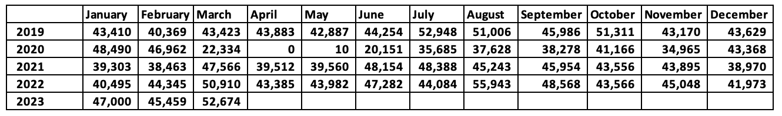
Items Received Day-to-Day in 2022

Delivery volume is normally highest on Tuesday as illustrated in this sample. After a Monday holiday this peak in volume is higher because library customers do not need to visit the library to request items.

Day | Items Received
Monday | 2,281
Tuesday | 3,295
Wednesday | 2,132
Thursday | 2,124
Friday | 2,012

Exhibit A: Part 3: Branch Delivery Sample
Summary of Results of a Branch Delivery Sample on March 13-17, 2023

See original data in separate spreadsheet: Exhibit A – Part 3.

All branches participated. A small amount of data was estimated or adjusted to avoid bias. We asked each branch to count the following items for one week in March.

Blue and grey totes and Items shipped and received (counting full, less than half full, and total)
If multiple totes were shipped or received from any library.
Were any totes left behind? The results were negligible during this average delivery week.
How long a sample of items were on hold upon receipt, i.e., turnaround time.
Detailed instructions are below.

We also asked delivery staff to record the number of totes on the truck at the beginning end of each route.

Turnaround time was impressive as measured by how many days between the time a hold was placed and delivery. The shipping turnaround time is likely to be even faster because there is s delay between a patron placing a hold and shipment. Despite this delay, 3% of items were delivered with same day turnaround.

Mon 2.9 days (includes Sat & Sun)
Tues 1.6 days
Wed 1.2 days
Thurs 1.2 days
Fri 1.3 days

Multiple Tote Shipments
We examined the source and destination of totes when a library shipped or received multiple totes from any branch on a single day.

These figures may demonstrate the influence of preferring holds within a library’s county. Proximity may also be a factor.

84 Total Multiple Totes
65 Within same county (77%)
10 Out of county (12%)
9 To or from SMRL (11%)

Total Totes and Items Shipped

Trends of shipping for SMRLA and the libraries is illustrated in the four charts below.

The number of totes shipped varies little during the week despite the increased number of items shipped on Monday and Tuesday because each library normally ships at least one tote to each destination daily. The number of full totes is higher on Monday and Tuesday.

The charts showing items shipped and received illustrate the daily fluctuations.

Delivery Team, Tote Count Study
Count totes before unloading the truck at SMRLA/HALL and then count totes after loading the truck at SMRLA/HALL. All in the morning

Day | Monday | Tuesday | Wednesday | Thursday | Friday
# of totes before unloading truck  in the morning | 81 | 95 | 89 | 81 | 84
# of totes after  loading truck in the morning | 88 | 98 | 85 | 86 | 86

Day | Monday | Tuesday | Wednesday | Thursday | Friday
Mail totes before loading truck | 1 | 1 | 1
# of mail totes after  loading truck in the morning | 0 |  |  | 1 | 1

Day | Monday | Tuesday | Wednesday | Thursday | Friday
MISCELLANEOUS  Before loading truck |  |  |  | 1
MISCELLANEOUS
After loading truck

Cover Letter for Branch Survey March 2023

Dear Branch Manager,

SMRLA is conducting a delivery study to optimize our current services and plan for the future.
Accurate data about lending and borrowing at each branch is critical to this study.

We ask your assistance with a one-week survey of incoming and outgoing totes and items. Your participation is essential for the success of our study. Please share with the appropriate staff members to complete this five-day survey. Susan Grant will be discussing this at the March 1 Circulation Supervisors meeting. We understand that this will entail additional work at your branch and thank you for your participation.

Greg Pronevitz, our consultant on this project, has designed an Excel spreadsheet for each branch to complete during the sample week of March 8-14, 2023 (see attached). We also provide a version that can be printed. We are seeking data during normal delivery. If there is an interruption or curtailment, SMRLA will inform you by email. We will resume on that day of the week during next week. For example, if delivery is normal Monday and Tuesday but we had to curtail services on Wednesday, we will ask you to hold off on tallying the Wednesday sample until the following week.

The first worksheet is the blank which we ask you to complete and return to Greg Pronevitz. If you would like to print the worksheet to work with, please do so and scan it when complete and send to Greg Pronevitz via email. The second worksheet in the Excel version is a sample to demonstrate how to complete the survey.

We are seeking information on:

- A count of incoming and outgoing Blue totes and items (contents of tote, e.g., books, DVDs, etc.)
- A count of totes that were shipped and/or received that were full and not full. If a tote is half-full or more, count as full. If in doubt, count as not full. However, do not count empty totes. Please list empty totes in the notes section at the end of the survey.
- A random sample of how long one item in each tote has been in transit (age). That is if a sampled item was put in transit the same day it was received, days in transit equals 0. If an item was put in transit the day before it was received, days in transit equals 1, etc. To select a random item, pick one item from the middle of the tote.
- A list of branches for which your branch shipped more than one tote during the survey week.
- A count of incoming and outgoing Grey totes and items.
- Any notes or comments you may have about delivery services or specific situations in your branch that may affect delivery during the sample period. For example, note how many story time totes were shipped on a given day.

Please direct any questions to Greg Pronevitz greg@pronevitzconsulting.com.

Thanks in advance for your participation.

Exhibit B: SMRLA Drivers Manual July 2021 revision

Note: this document is for information only from 2021 and may contain obsolete information.

Exhibit B (see separate PDF Document)

Exhibit C: Containers and Labels
Totes
- Blue Orbis FP151
- Grey Orbis FP151
- Storytime
- USPS

Vast majority of totes shipped are as follows:
Manufacturer: Orbis
What is the stock number: FP151
Distributer Global Industrial
Color: Gray for new materials, blue for ILL/books going between branches
External dimensions in inches: 22-3/10 x 13 x 12-4/5 tall
Internal dimensions in inches: 18.5 at base (20 at top) length x 11.75 tall x 10.5 at base (11.5 at top) wide
Lids: interlocking
Max tote weight: 40-50 pounds. We encourage libraries to leave two inches of empty space at top to keep weight down.
See photos below.
Average capacity: estimated 30-40 items and varies based on material.

Totes are labeled with a card in an external clear protector with the four-character designation of the destination (see photos below)
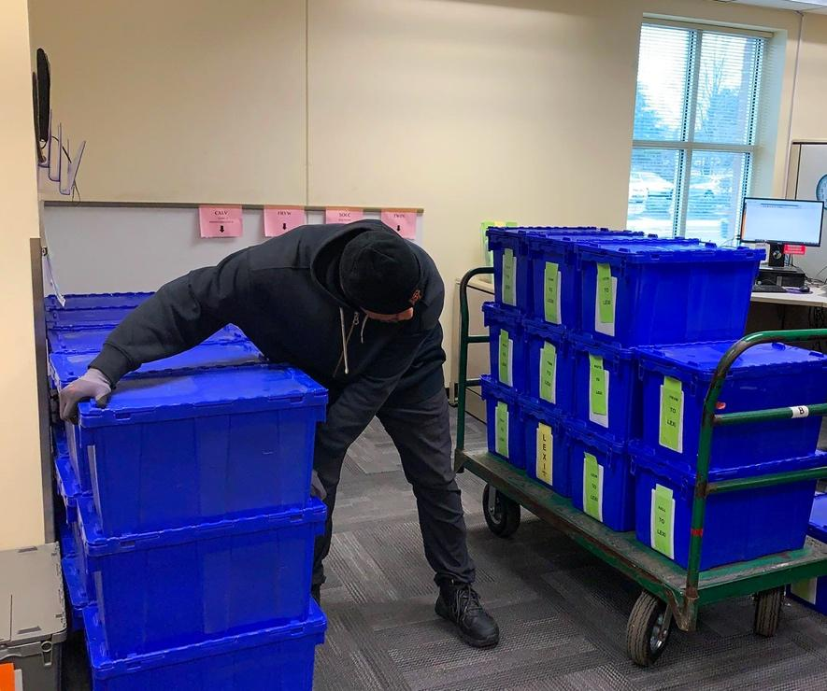

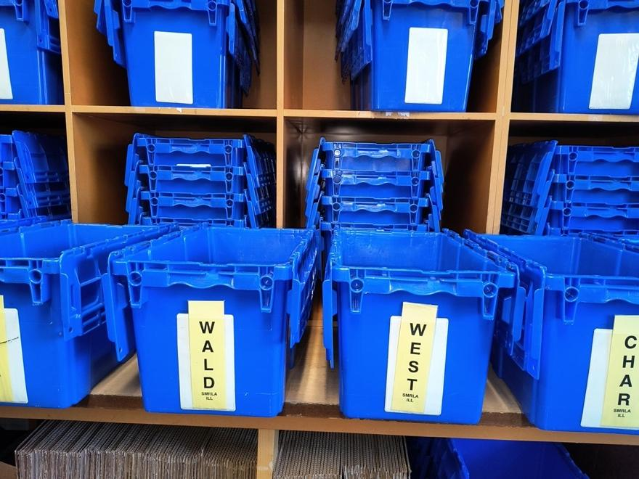

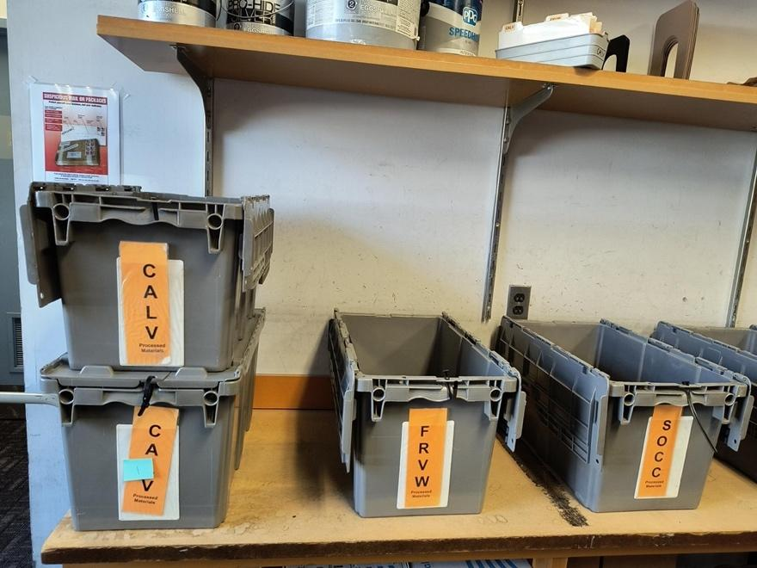

Other Containers

Canvas Bags are used as containers for delivery to the two weekly stops. They may also be used occasionally for other purposes. See photo below.

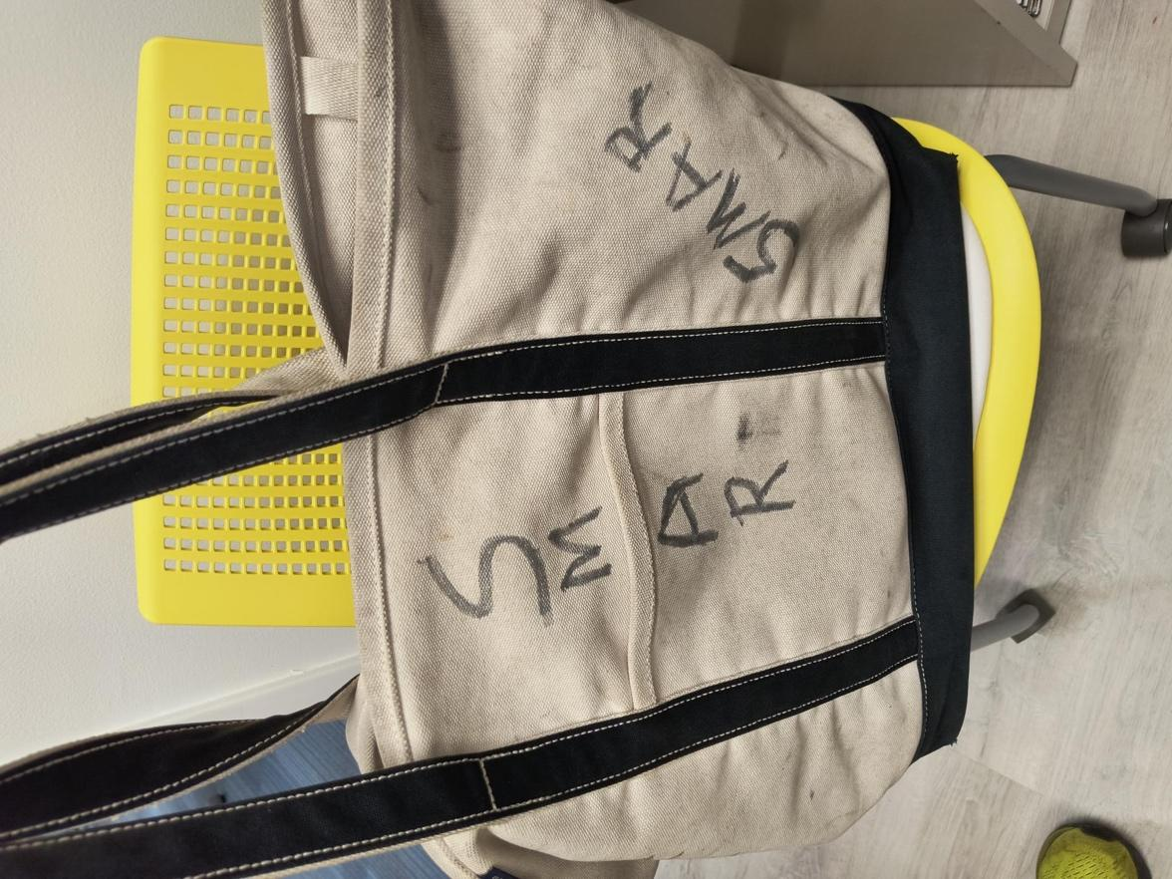

Storytime kits occasionally kits are shipped between libraries. This cargo is much lighter than the standard tote. During a recent one-week sample six kits were shipped and four were received by various branches. See clear containers in photo below.

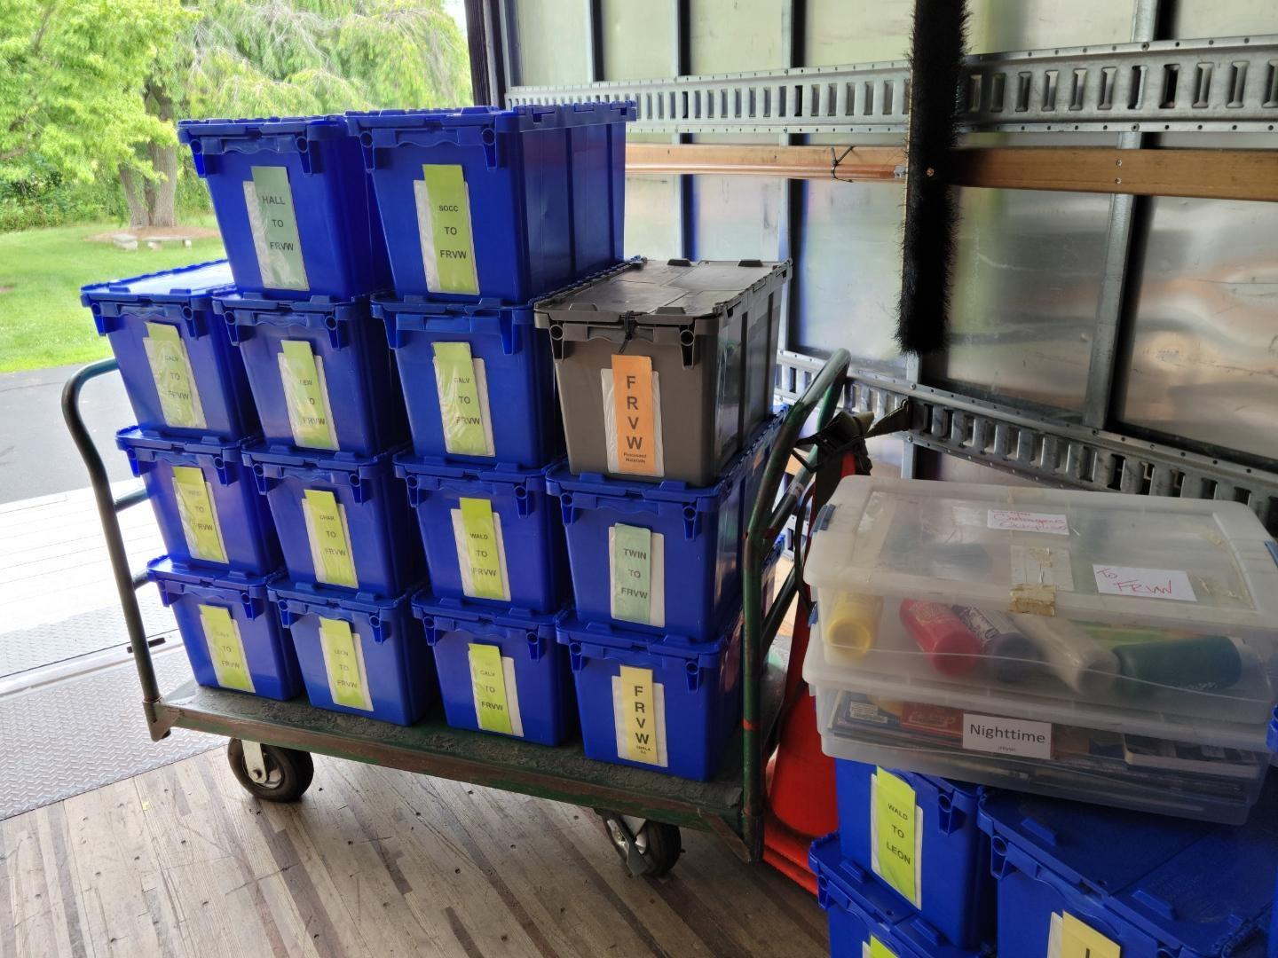

USPS mail totes are used for outgoing mail dropped at the Charlotte Hall Post Office daily. Normally there are two or three outgoing totes and one or two incoming totes. The driver enters the post office and identifies him/herself as SMRLA and mail is turned over to him/her. See photo below.
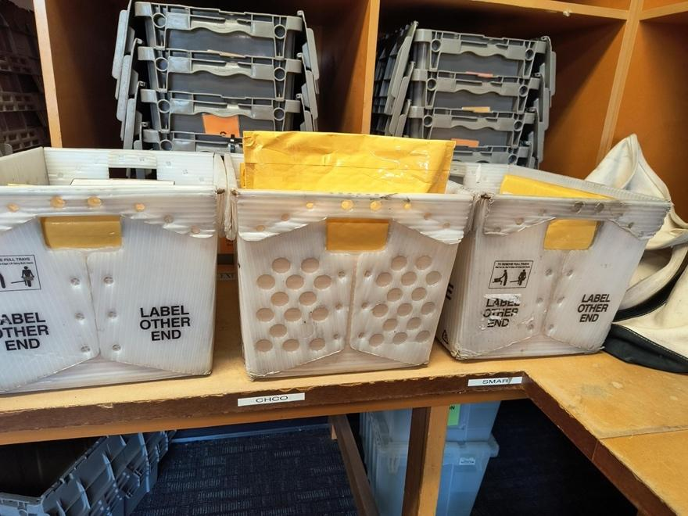

Exhibit D: Sorting
Current practice is sorting on-board. We use a 26’ straight truck configured as illustrated below and in Exhibit B: SMRLA Drivers Manual.

This provides space for 9-12 totes for each of the 12 daily delivery stops at libraries. All totes are delivered along the route. Totes are not unloaded except at their destination. The driver and helper do not remove items from totes. As items are processed, library staff, learn the destination from SMRLA’s Polaris system and sort into the proper tote for that destination. The totes are labeled by destination for pick up by SMRLA driver and helper.

This system results in most deliveries including at least 11 totes and the pick-up will normally be a similar number. Many stops receive more. See Exhibit A: SMRLA Delivery Data for four-character delivery codes and sample data. Totes are labeled with a four-character designation. See Exhibit C: Labels and Totes for illustrations. Items are not labeled.

There are two stops that are serviced weekly. These are low volume stops and deliveries and pick-ups are normally a canvas bag full of library materials.

There is one stop that is on demand. This low volume stop is serviced only when SMRLA has an item to be delivered there. Cargo is one or two books.

Other cargo. Libraries occasionally ship other cargo. Often this is a “Kit”.

Alternative proposals to enhance efficiency without putting a burden on libraries are welcome.

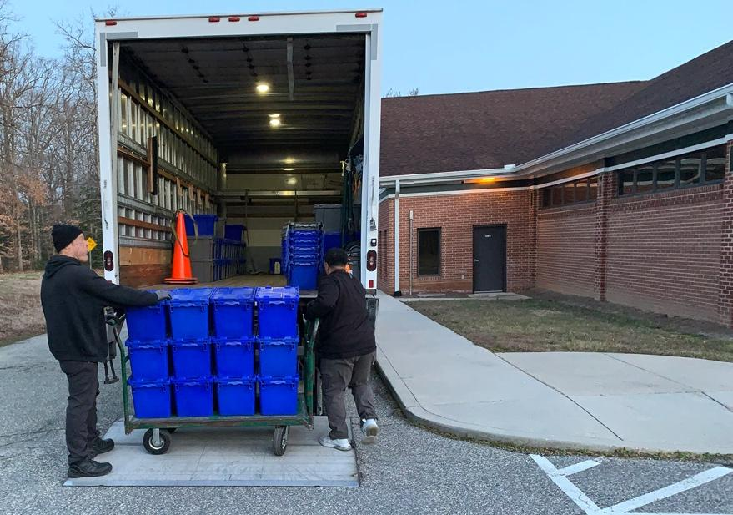
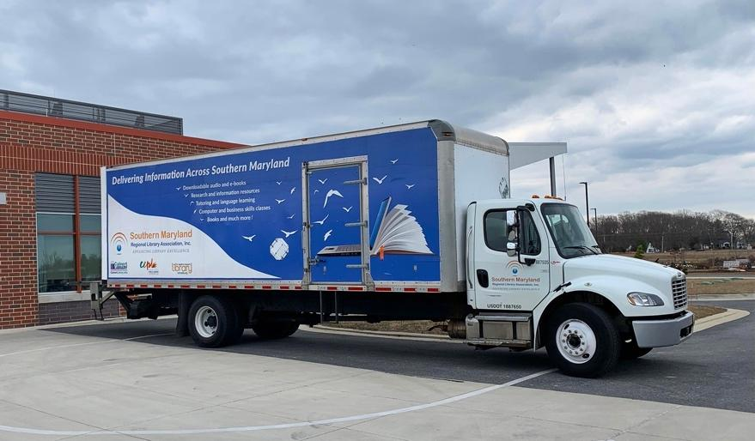
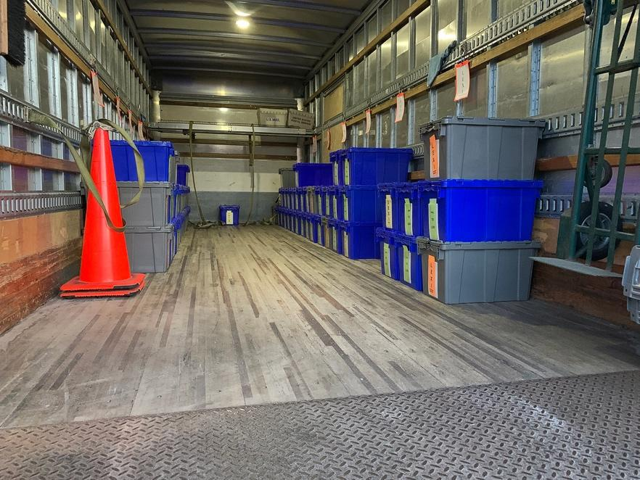
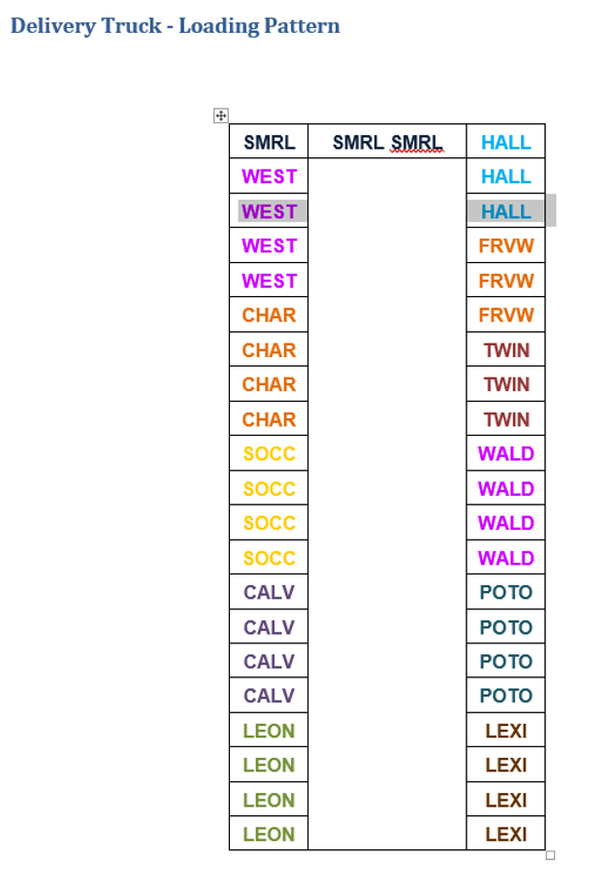

Exhibit E: Glossary of Terms
Damaged items
If an item is damaged in transit, for example a tote is spilled in a puddle during delivery. Wet items that cannot be used are damaged. Other examples would be a spilled tote and an item is torn or broken.

Incomplete stop
A stop at which the driver failed to pick up and/or deliver all designated cargo. For example: there was not enough room on the truck to pick up 18 bins that were ready for pick up and the driver could only accept 15.

Key performance indicators (KPI) as reported by libraries and/or SMRLA.

- Quality of service with turnaround time of next working day for 90% of materials and 99% by the following working day.
- Quality of service with on time delivery to all stops on 99% of working days.
- Quality of service with 99% accuracy of delivery of totes for all stops.
- Quality of service with no damage to library materials or property.
- Vendor shall provide SMRLA and libraries with prompt reimbursement within 14 days to cover standard library replacement costs for damaged or lost materials for which a valid claim was submitted.
- Quality of service with 99.9% complete stops.
- Quality of service with Contractor informing SMRLA within one hour when any route is delayed, curtailed, or canceled.
- Quality of service with 99.9% accurate invoices.
- Quality of service with 99% of weekly reports provided by Tuesday of the following week.
- Quality of service with drivers maintaining a neat, well-groomed appearance.
- Reliable backups for personnel and vehicle with a quality standard of 99% all scheduled stops are made.
- Recovery after issues, e.g., weather emergency, staff absence, or vehicle problems, in which normal service is resumed within two working days.

Lost or missing items
An item that was shipped by a library and not received within seven days according to SMRLA’s computer records.

One-Hour Delivery window
The scheduled stop times are listed in Exhibit A. The one-hour delivery window is one hour prior to and one hour after the designated delivery time.

Standard library replacement costs including processing costs.
Libraries purchase materials from designated vendors with whom discounts, and processing costs are agreed upon in advance. In addition, bringing an item into the collection involves processing costs for cataloging and labeling for which we have established a fee of $5.00 per item in addition to the actual library replacement cost. We will advise libraries to refrain from shipping items valued at more than $250.00 and will establish this figure as the maximum reimbursement per item.

Response Template

Following is a template of attachments in the sequence required for this RFP as described in the proposal requirements. Respondent may use this template or other format. All attachments must be completed adhering to the proposal requirements.

Attachment A: Cover Letter
Insert cover letter here according to instructions in the Proposal Requirements (above).

Attachment B: Table of Contents
Insert table of contents here according to instructions in the Proposal Requirements (above).

Attachment C: Attachment Checklist

__________________________________
Respondent Company Name

Please complete this checklist to confirm that the items listed below have been included in your proposal. Place a checkmark or “x” next to each item submitted to SMRLA. For your proposal to be considered, all required attachments must be returned, including this checklist. Submit one copy of your proposal in a sealed package.

Attachment Attachment Name

_____ A Cover Letter

_____ B Table of Contents

_____ C Attachments Checklist

_____ D Minimum Qualifications

_____ E Proposal Questionnaire

_____ F Cost Proposal

_____ G Respondent References

_____ H Authorization Agreement

_____ I Certificate of Independent Price Determination

Attachment D: Minimum Qualifications

A Respondent must meet all the following minimum qualifications to SMRLA’s satisfaction to be given further consideration. Failure to satisfy any of the minimum qualifications may result in the immediate rejection of the proposal.

As of September 1, 2023 both the Respondent and its key personnel meet all the following minimum qualifications:

- The Respondent is submitting one proposal or multiple proposals that differ significantly from each other.
Yes _____ No _____

If there are multiple proposals, this is proposal _____ of _____, e.g., 1 of 2, 2 of 2, etc.

- The Respondent has the resources and ability to provide delivery and sorting services during the proposed contract term.
Yes _____ No _____

- The Respondent has at least five years of experience with delivery and sorting services.

Yes _____ No _____

- The Respondent has at least three professional references that demonstrate and evidence the ability to perform the required services.

Yes _____ No _____

- The Respondent is licensed to do business in the state of Maryland.
Yes ______ No ______

- The Respondent affirms that all employees, agents, and contractors will fully comply with Maryland and US law, regulation, and licensing.
Yes ______ No ______

- The Respondent affirms that if it shall provide single point of contact to handle customer service for SMRLA and its member libraries throughout the term of any future agreement.

Yes ______ No ______

Attachment E: Proposal Questionnaire

Part 1 - Attachment E: Proposal Questionnaire

This proposal questionnaire is intended to provide SMRLA with specific information concerning the Respondent’s capability to provide services as described in the RFP. Please be as concise as possible. Type each question in the same order as listed in the questionnaire.

- Provide a corporate profile describing your company, the year company was founded, primary business(s), length of time the company has been providing delivery and sorting services, number of employees, the physical location(s) of current operations and offices, and clarify whether drivers and other staff are company employees, subcontracted through another company, or individual subcontractors. Describe licensing, incorporation, and other qualifications that permit your firm to perform delivery and sorting services in the State of Maryland

- Provide an organization chart for your company, a description of the lines of communication, and the responsibilities at each corporate level as it pertains to this RFP.

- Provide detailed project plan describing how your firm will perform delivery and sorting services under an agreement resulting from this RFP. Include details on titles of all employees, types of contactors, size and capacity of vehicles, locations of any offices or operations centers route(s), schedules, plans for backup to cover employee absences and vehicle repairs, plans to cover busier periods after holidays, weather emergencies, employee absences or vehicle repairs, a clear explanation of how, when, and where daily sorting will take place, etc.

- Provide a recommended transition plan that describes the steps the Respondent will take to begin providing the services described in this RFP.

- Provide a general description of how your company will be able to provide the experience, ability, and financial standing necessary to meet the requirements set forth in this RFP.

- Provide a complete balance sheet or annual report (verified by a certified public accountant) for the last recent three years of operation.

- Provide a description of experience with route services, courier services or related delivery services, including both library and other types of customers.

- Provide a list of all current customers. If the number exceeds 15, list only those in the Washington DC/Maryland area.

- Provide a complete list of customers that have discontinued or terminated your company’s services in the last five years and the reason(s) why.

Part 2 - Attachment E: Proposal Questionnaire

Indicate responses by your company with an “x”, i.e., [x].

The SMRLA preferred responses are marked as “Preferred” when applicable.

If your bid varies from the description here, please describe your response in the following box marked “other”.

Provide additional details and provide clarifying explanation in the notes area and/or in a clearly labeled attachment.

E.2.1 Route Logistics

1 | [ ] | Vendor shall provide direct delivery and pickup services to all location addresses according to the schedule listed in Exhibit A to a designated location within each building according to instructions provided by SMRLA. Preferred  Notes:
 | [ ] | Other:
2 | [ ] | The vendor shall provide scheduled service five days a week (Monday through Friday) to all delivery stops (unless less frequent service is indicated in Exhibit A). Preferred  Notes:
 | [ ] | Other:
3 | [ ] | The vendor shall provide dedicated service on vehicles providing SMRLA delivery services, i.e., SMRLA cargo is not commingled with other customers’ cargo. Preferred  Notes:
 | [ ] | Other:
4 | [ ] | The vendor shall stop at each location on every day it is scheduled for delivery and pickup regardless of whether the driver has any containers to deliver. Preferred  Notes:
 | [ ] | Other:
5 | [ ] | The vendor shall provide delivery and pickup of all material at any location at the same time every day the location is scheduled for service, within a one-hour delivery window. Preferred  Notes:
 | [ ] | Other:
6 | [ ] | The vendor shall notify SMRLA within one hour of discovery that any route will be run behind or ahead of schedule or will not run that will affect vendor’s ability to meet the one-hour delivery window. Preferred  Notes:
 | [ ] | Other:
7 | [ ] | The vendor must be able to stop delivery to accommodate scheduled closings at individual libraries according to a list provided in advance. Preferred  Notes:
 | [ ] | Other:
8 | [ ] | The vendor must be able to stop delivery to accommodate an emergency closing at an individual location with 2-hour notice. Preferred  Notes:
 | [ ] | Other:
9 | [ ] | The vendor shall safeguard against damage to library materials. Explain what other kinds of materials will be delivered in the same vehicles and how the library materials will be protected. Exposure of library materials to hazardous, odiferous, wet or dirty materials is not acceptable. Explain how materials shall also be protected against exposure to inclement weather at all times. Preferred  Notes:
 | [ ] | Other:
10 | [ ] | The vendor shall provide its COVID-19 policies and agree to provide services while accommodating reasonable policies of SMRLA and/or its member libraries with regard to infection control including contactless delivery when requested. Preferred  Notes:
 | [ ] | Other:
11 |  | Vendor Employee vs Independent Contractor and/or subcontractor for services provided under this RFP.
 | [ ] | Vendor employees shall provide at least 90 percent services using vendor facilities, vehicles, and supplies. Preferred  Notes:
 | [ ] | Vendor employees shall provide at least 50 percent services using vendor facilities, vehicles, and supplies. SMRLA second choice  Notes:
 | [ ] | Vendor employees shall provide less than 50 percent services using vendor facilities, vehicles, and supplies. SMRLA third choice  Notes:
 | [ ] | Other:
12 | [ ] | Vendor has provided a list of planned subcontractors (if contractors are to be used).  Notes:
 | [ ] | Other:

E.2.2 Labeling, Containers, and Sorting

1 |  | Labels
 | [ ] | Vendor shall allow use of all current labels for all routes. Preferred  Notes:
 | [ ] | Vendor shall allow use of some current labels, exceptions noted.  Notes:
 | [ ] | Vendor shall provide new labels as noted. Provide examples.  Notes:
 | [ ] | Other:
2 |  | Containers (two preferred responses)
 | [ ] | Vendor shall allow use of all current containers for all routes. Preferred  Notes:
 | [ ] | Vendor shall provide new containers as noted. Provide examples. Preferred  Notes:
 | [ ] | Vendor shall allow use of some current containers, exceptions noted.  Notes:
 | [ ] | Other:

E.2.3 Administration and Customer Service

1 |  | Project Plan
 | [ ] | Vendor has attached a Project Plan for initiating and administering the service, including clear explanations about staff, equipment, routing, and sorting. Preferred  Notes:
 | [ ] | Other:
2 |  | Transition Plan
 | [ ] | The vendor has attached a transition plan for the smooth transition from current delivery service to vendor’s delivery. The transition will not result in any days without service for participating libraries. Preferred  Notes:
 | [ ] | Other:
3 |  | Vehicles and Operators
 | [ ] | Vendor shall furnish appropriate vehicles and trained operators, sufficient in size and power to transport without damage, current and forecasted daily volumes. The vendor’s delivery trucks must be covered and protected from the elements. The vendor shall also furnish sufficient back‐up vehicles and trained operators to insure uninterrupted delivery service during routine maintenance and emergency backup. Preferred  Notes:
 | [ ] | Other:
3 |  | List of Trucks
 | [ ] | Vendor has provided a list of trucks (by size, capacity in cubic feet) that will be used to accommodate all routes in this proposal. Preferred  Notes:
 | [ ] | Vendor shall provide a list of trucks (by size, capacity in cubic feet) that will be used to accommodate all routes in this proposal within 14 days of contract execution.  Notes:
 | [ ] | Other, describe in detail:
4 |  | Routes
4a | [ ]  [ ]  [ ] | Vendor shall employ a single route or multiple routes to meet requirements of this RFP.  Preferred  Single route  Multiple routes  Notes:
 | [ ] | Other, describe in detail:
4b | [ ] | Vendor shall organize and manage routes, as well as transfer of materials between routes. Preferred  Notes:
 | [ ] | Other, describe in detail:
4c | [ ] | Vendor has designed and attached a schedule of deliveries for most stops, subject to SMRLA approval. Preferred  Notes:
 | [ ] | Other, describe in detail:
5 |  | Sorting
 | [ ] | Vendor shall do all sorting on board the delivery truck or in climate-controlled indoor vendor facilities with sorting accuracy of 99.9% or better and not require any presorting by the libraries.  Preferred  Notes:
 | [ ] | Other:
6 |  | Customer Service
6a | [ ] | Vendor shall provide a single primary customer service representative assigned to this contract who will handle all service issues, including missed stops, scheduled changes, expected materials that have not been delivered, damaged or lost materials and other service issues that may arise. Preferred  Notes:
 | [ ] | Other:
6b | [ ] | Vendor shall meet regularly with SMRLA during the term of this agreement to review key performance indicators (KPI). Preferred
 | [ ] | Other:
6c | [ ] | Vendor shall provide a designated contact person for resolution of questions relating to fiscal issues, e.g., invoicing, payment, and damaged/lost materials claims. Preferred  Notes:
 | [ ] | Other, describe in detail:
6d |  | Vendor shall respond to requests for the resolution of questions relating to all services within one (1) hour during the workday (8:00am-5:00pm) and by 9:00 the following workday for after-hours requests. Preferred  Notes:
 | [ ] | Other:
6e |  | Vendor shall resolve any service problems, such as missed stops, within one (1) business day. Preferred  Notes:
 | [ ] | Other:
6f | [ ] | Vendor has attached a damaged and lost materials claim procedure. If problems are to be reported electronically, please supply a website URL and trial login for the purposes of this response. Preferred  Notes:
 | [ ] | Other:

E.2.4 Driver Requirements

1 | [ ] | Vendor shall conduct appropriate background checks on all company employed or subcontracted drivers, specifying that they have active valid driver’s licenses. Please describe criteria used. Preferred  Notes:
 | [ ] | Other:
2 | [ ] | Vendor shall conduct annual motor vehicle driving record checks on all company employed or subcontracted drivers. Please describe criteria used. Preferred  Notes:
 | [ ] | Other:
3 | [ ] | Vendor shall ensure that every vendor employee or subcontractor delivering to a SMRLA location must display visible identification such as a standard uniform, tag or badge which clearly identifies the individual as a representative of the vendor. Describe the identification in the “Notes”. Preferred  Notes:
 | [ ] | Other:
4 | [ ] | Vendor shall ensure that all drivers must be bonded and/or insured to protect SMRLA and its members from liability and property loss. Vendor shall provide appropriate documentation for initial drivers and when new drivers are hired. Preferred  Notes:
 | [ ] | Other:
5 |  | Vendor shall ensure that all drivers behave in a courteous manner and exhibit a neat, well-groomed appearance at all times when providing services to SMRLA and its libraries. Preferred  Notes:
 | [ ] | Other:

E.5 Performance Specifications

1 | [ ]  [ ] | Vendor shall ensure the delivery of items between locations receiving five days per week service within:  One (1) business day, excluding weekends and holidays, for 90% of items and within two (2) business days for 99% of items. Preferred  Two (2) business days, excluding weekends and holidays, for 90% of items and within three (3) business days for 99% of items.  Notes:
 | [ ] | Other:
2 | [ ] | Vendor shall ensure on time delivery to all stops:  On 99% of all working days per year. Preferred  Notes:
 | [ ] | Other:
3 | [ ] | Vendor shall ensure delivery accuracy of:  99% of all totes delivered to all stops. Preferred  Notes:
 | [ ] | Other:
5 | [ ] | Vendor shall capture and provide the following data to SMRLA in a weekly report to be delivered by Tuesday.  Daily list of stops made on schedule  Daily list of scheduled stops not made  Daily list of stops made outside of scheduled one-hour delivery window  Daily list of incomplete stops  Daily list of number of containers with items left at warehouse upon departure of vehicle(s)  End of the week inventory of empty containers on hand  Preferred  Notes:
 | [ ] | Other:
6 | [ ] | Vendor shall provide SMRLA with a weekly summary of service issues and their dates and the dates of resolution. Preferred  Notes:
 | [ ] | Other:
7 | [ ] | Vendor shall provide SMRLA and libraries with prompt reimbursement within 14 days to cover standard library replacement costs for damaged or lost materials for which a valid claim was submitted. Preferred  Notes:
 | [ ] | Other:
8 | [ ] | Vendor shall adjust its weekly invoice to provide a five percent (5%) discount in any week following a week when there were multiple vendor failures to maintain agreed upon quality of service (Key performance indicators) and in any week following three consecutive weeks with a single vendor failure. Preferred  Notes:
 | [ ] | Other:

Attachment F: Cost Proposal

Indicate responses by your firm by filling in responses below and/or with an “x”, i.e., [x]. Provide additional details and describe any exceptions in the notes area and/or in a clearly labeled attachment.

1 |  | Annual cost of proposed service.
 | $___________ | Annual cost (based on per stop cost). Preferred  Notes:
 | $___________ | Annual cost (based on other criteria (please describe)).  Notes:
 | [ ] | Other:
2 |  | Per stop cost.
 | $___________ | Per stop cost. Pricing is based on actual number of complete, on-time, complete stops made during a standard invoice period. Preferred
 | [ ] | Other:
4 | [ ] | Vendor shall maintain proposed costs for a one-year agreement with three renewals on mutually agreeable terms. Preferred  Notes:
 | [ ] | Other:
4 | [ ] | Vendor shall describe factors which will be considered for three renewals on mutually agreeable terms. Please describe in the notes. Preferred  Notes:
 | [ ] | Other:
5 | [ ] | Vendor shall maintain proposed costs unless volume of items shipped varies by more than ten percent. Preferred  Notes:
 | [ ] | Other:
6 | [ ] | Vendor shall maintain proposed costs unless number of stops varies by more than ten percent. The anticipated reduction in the number of stops because many schools and higher education libraries reduce stops in the summertime will not be considered a variance related to the abovementioned ten percent. Preferred  Notes:
 | [ ] | Other:
 |  | Fuel Costs
7a |  | Vendor shall agree to maintain annual pricing with regard to fuel prices unless the price for unleaded regular gasoline reaches or exceeds $4.00 per gallon for four consecutive weeks. Preferred  Notes:
 | [ ] | Other:
7b | [ ] | Vendor has supplied a fuel surcharge proposal that clearly describes the amount of surcharge and the methodology for calculation which clearly describes how the surcharge is based on the cost of fuel only. Note: SMRLA cannot accept a proposal for a fuel surcharge that becomes effective when fuel prices are below $4.00 per gallon according to the U.S. Energy Information Administration.  Notes:
 | [ ] | Other:
8a |  | Invoicing
 | [ ] | Vendor shall provide accurate weekly invoicing. Preferred  Notes:
 | [ ] | Other:
8b | [ ] | Per stop invoice
 | [ ] | Each invoice will include the cost of each on-time, complete stop made during the invoice period. Stops made outside the one-hour delivery window and incomplete stops shall not be billed without the prior written consent of SMRLA, for example, such permission may be granted during weather emergencies. Preferred  Notes:
 | [ ] | Other:
9 |  | Invoice adjustments (credits) for non-standard performance
9a | [ ] | When multiple problems are reported, vendor shall take immediate corrective action. Preferred
 | [ ] | Other:
9b | [ ] | Vendor shall report all complete and incomplete stops to SMRLA on a weekly report. Preferred  Notes:
 | [ ] | Other:
10 | [ ] | Vendor shall be responsible for the payment of all charges incurred by SMRLA and or libraries in performance of delivery and sorting services, e.g., false alarm fees, parking fees and violations, and damage to property. Preferred  Notes:
 | [ ] | Other:

Attachment G: Respondent References
List three references to which the Respondent has provided organizational workflow analysis within the past five year(s).

Failure to complete and return this Attachment will cause your proposal to be rejected.

Reference 1
Name of Reference
Street Address
City | State | Zip Code
Contact Person | Contact Title | Contact Phone Number
Email Address
Brief Description of Services Provided
Dates of Service
Reference 2
Name of Reference
Street Address
City | State | Zip Code
Contact Person | Contact Title | Contact Phone Number
Email Address
Brief Description of Services Provided
Dates of Service
Reference 3
Name of Reference
Street Address
City | State | Zip Code
Contact Person | Contact Title | Contact Phone Number
Email Address
Brief Description of Services Provided
Dates of Service

Attachment H: Authorization Agreement
Request for Proposal for SMRLA’s Delivery Study

We, [Enter Name], by our signature on this document certify the following:

- That we will operate in accordance with all applicable Maryland state and federal laws, regulations, and statutes.

- That the terms, conditions, warranties, and representations made within this RFP and our proposal shall be binding upon us and shall be considered a part of the contract as if incorporated therein.

- That the proposal submitted is a firm and irrevocable offer good for one year.

- That we have made examinations and verifications, and are fully conversant with all conditions under which services are to be performed for [Enter SMRLA Name].

- That negligence in the preparation or presentation of, errors in, or omissions from proposals shall not relieve us from fulfillment of any and all obligations and requirements in the resulting contract.

Respondent Name: ________________________________________________

Address: ______________________________________________________

City: _________________________________ State: ____ Zip: ________

E–mail Address: _________________________________________________

Web Site Address: _______________________________________________

Name of Authorized Representative: _________________________________

Title of Authorized Representative: _________________________________

_____________________________________________________________
Signature of Authorized Representative

Date Signed: ___________________________________________________

Attachment I: Certificate of Independent Price Determination
Both SMRLA and the Respondent shall execute this Certificate of Independent Price Determination.
Name of Respondent |  | Name of SMRLA

- By submission of this offer, the respondent certifies and, in the case of a joint offer, each party thereto certifies as to its own organization that in connection with this procurement:

  - The prices in this offer have been arrived at independently—without consultation, communication, or agreement—for the purpose of restricting competition, as to any matter relating to such prices with any other offeror or with any competitor;

  - Unless otherwise required by law, the prices which have been quoted in this offer have not been knowingly disclosed by the offeror and will not knowingly be disclosed by the offeror prior to opening the case of an advertised procurement, directly or indirectly to any other offeror or to any competitor; and

  - No attempt has been made or will be made by the offeror to induce any person or firm to submit, or not to submit, an offer for the purpose of restricting competition.

- Each person signing this offer on behalf of the offeror certifies that:

  - He or she is the person in the respondent’s organization responsible within the organization for the decision as to the prices being offered herein and has not participated, and will not participate, in any action contrary to (A)(1) through (A)(3) above; or

  - He or she is not the person in the respondent’s organization responsible within the organization for the decision as to the prices being offered herein, but that he or she has been authorized in writing to act as agent for the persons responsible for such decision in certifying that such persons have not participated, and will not participate, in any action contrary to (A)(1) through (A)(3) above and as their agent does hereby so certify; and he or she has not participated, and will not participate, in any action contrary to (A)(1) through (A)(3) above.

To the best of my knowledge, this vendor and its affiliates, subsidiaries, officers, directors, and employees are not currently under investigation by any governmental agency and have not in the last three years been convicted or found liable for any act prohibited by state or federal law in any jurisdiction, involving conspiracy or collusion with respect to bidding on any public contract, except as follows (provide detail):

Signature of respondent’s  Authorized Representative |  | Title |  | Date

In accepting this offer, SMRLA certifies that no representative of SMRLA has taken any action that may have jeopardized the independence of the offer referred to above.
Signature of SMRLA’s  Authorized Representative |  | Title |  | Date
Note: Accepting a Respondent’s offer does not constitute award of the contract

